

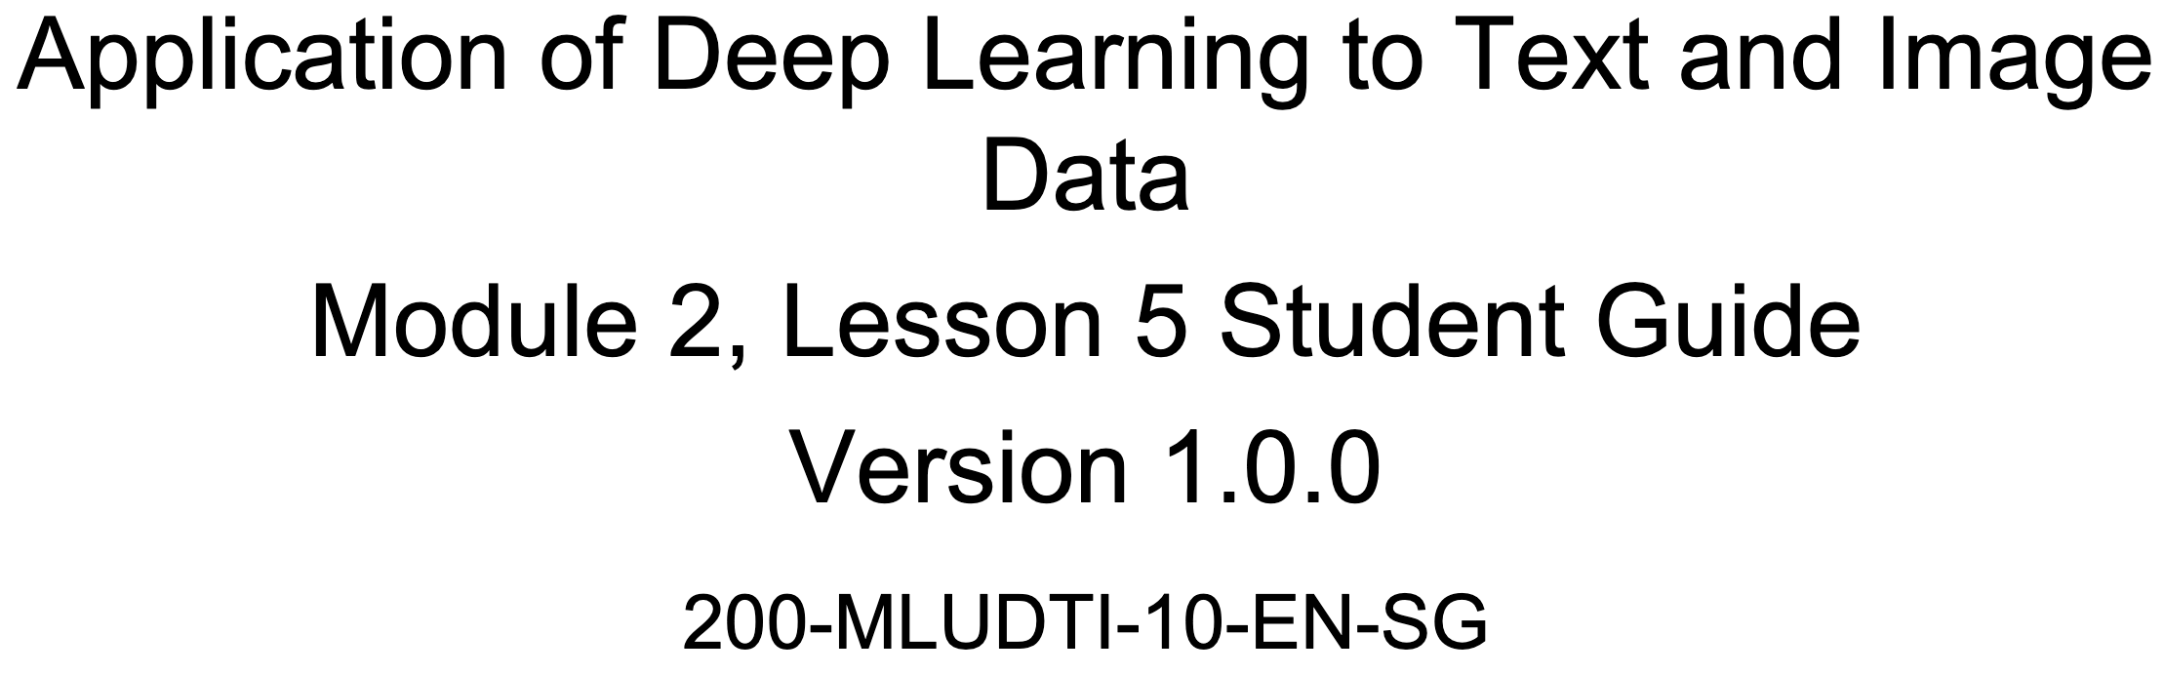





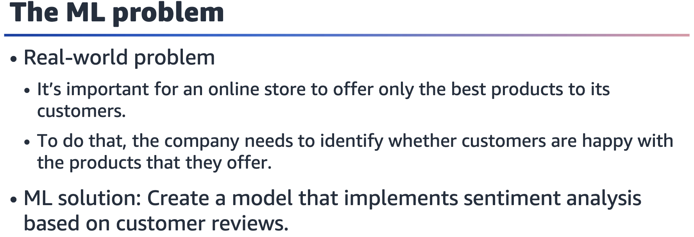

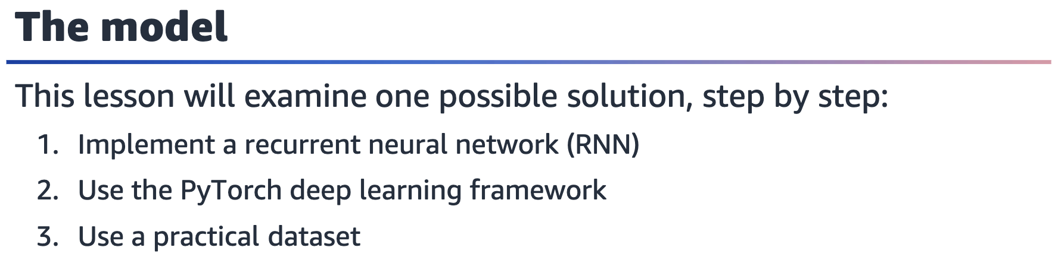

PyTorch is a popular deep learning framework that simplifies the processes of building, training, and evaluating deep neural networks. It uses automatic differentiation to compute gradients efficiently during backpropagation. PyTorch uses tensors (multidimensional arrays) for all data operations.

**Importing PyTorch libraries**

# Import the main PyTorch package

import torch

# Import submodules nn: neural netwk, optim: optimization algos

from torch import nn, optim

# Import classes to manipulate datasets and tensors

from torch.nn import BCEWithLogitsLoss

from torch.utils.data import TensorDataset, DataLoader

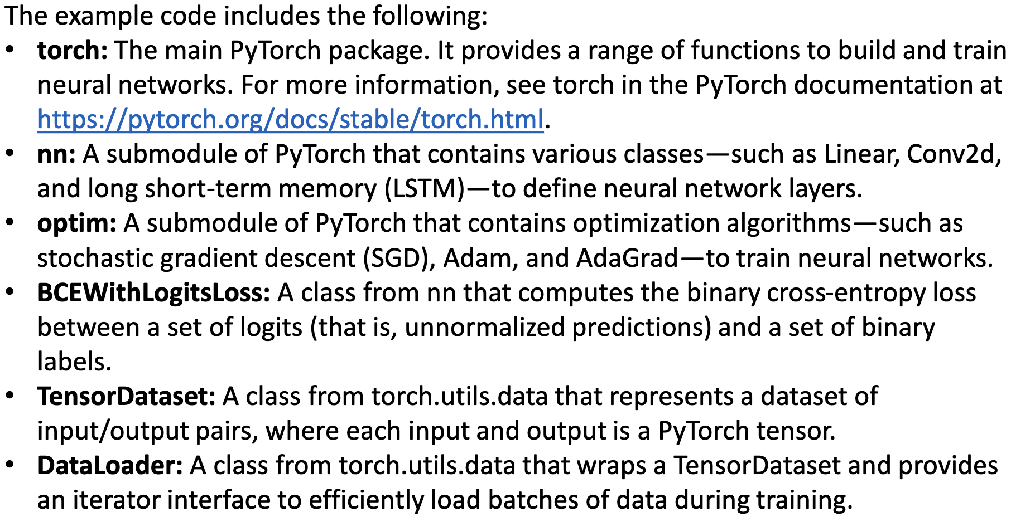

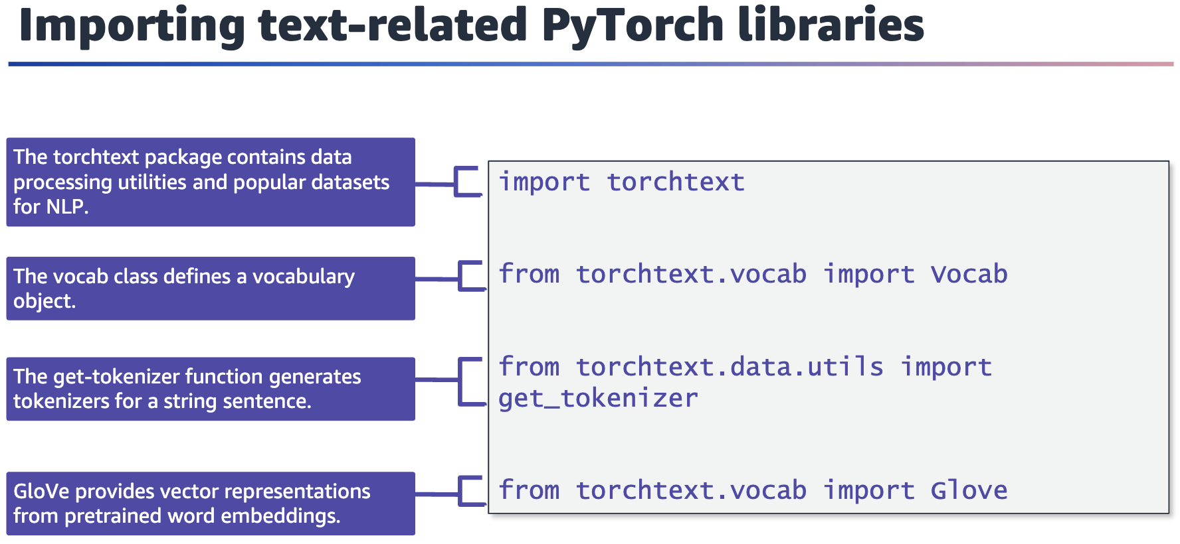

For information about the torchtext package, see the TorchText documentation at

<https://pytorch.org/text/stable/#torchtext>.

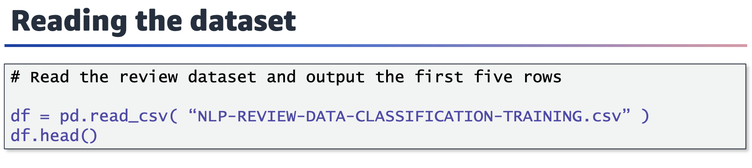

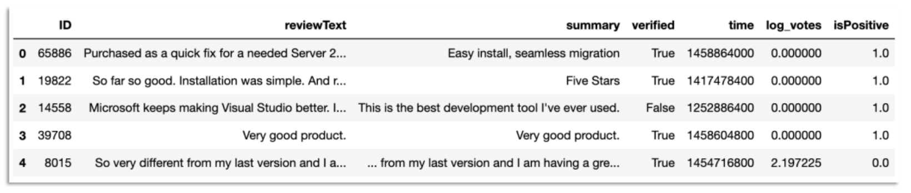

Screenshot of the first five rows of the DataFrame and their column names: ID, reviewText, summary, verified, time, log_votes, and isPositive.

The code snippet on this slide reads in a .csv file named NLP-REVIEW-DATA-CLASSIFICATION-TRAINING.csv (in my Notebook: AMAZON-REVIEW-DATA-CLASSIFICATION.csv) and assigns it to a Pandas DataFrame object that is named df. The .head() method is then called on this DataFrame object to display the first five rows of the DataFrame and the column names.

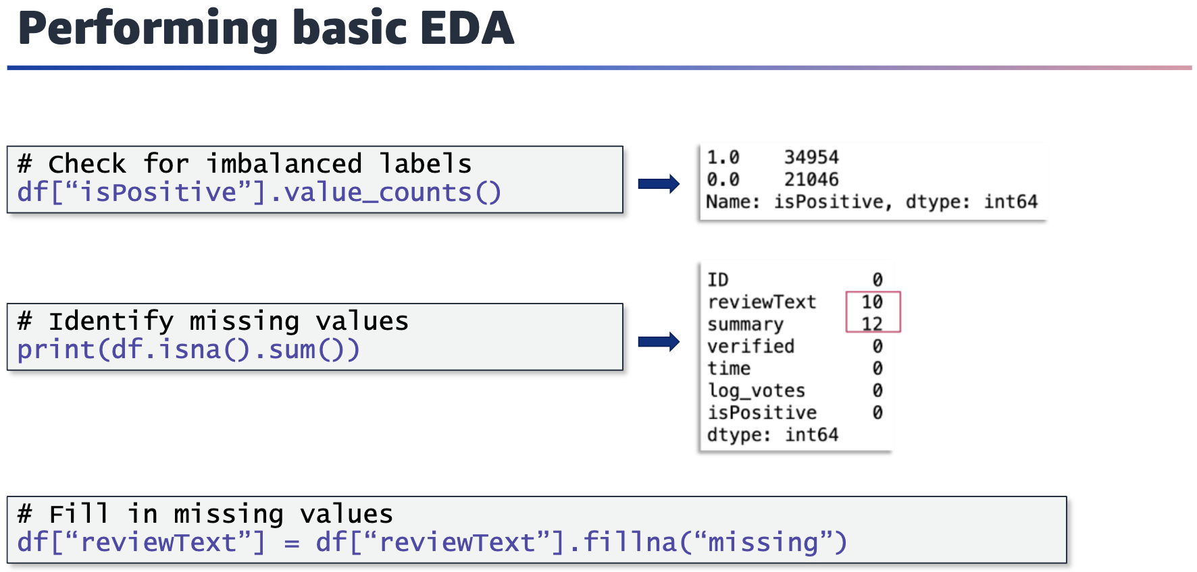

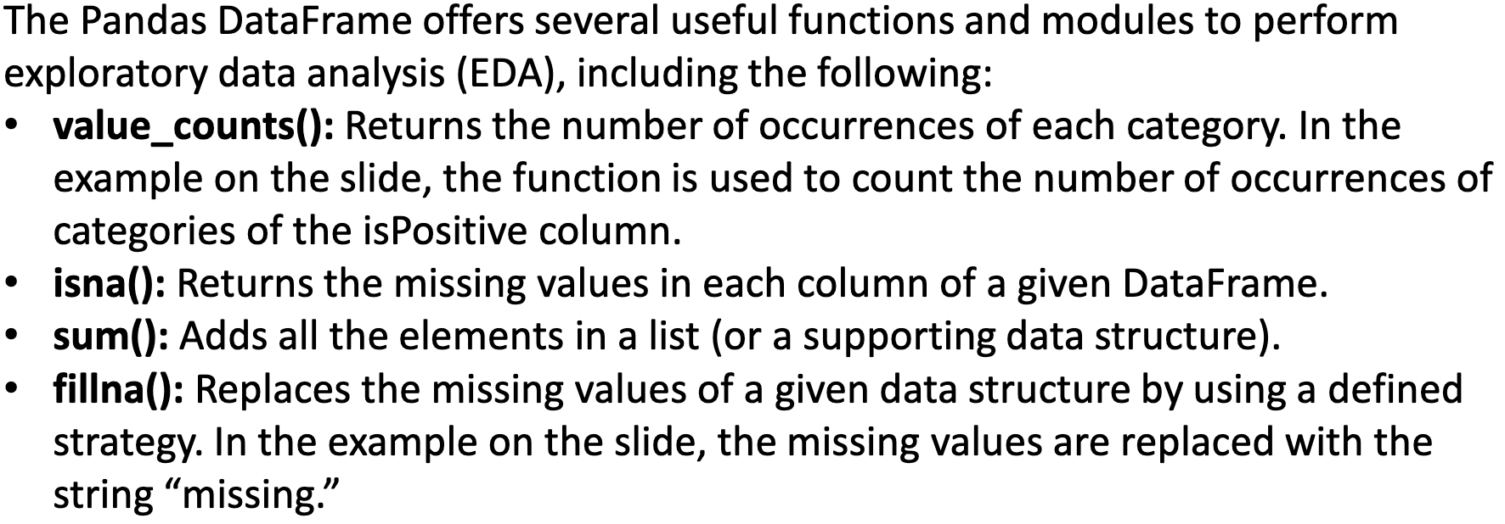

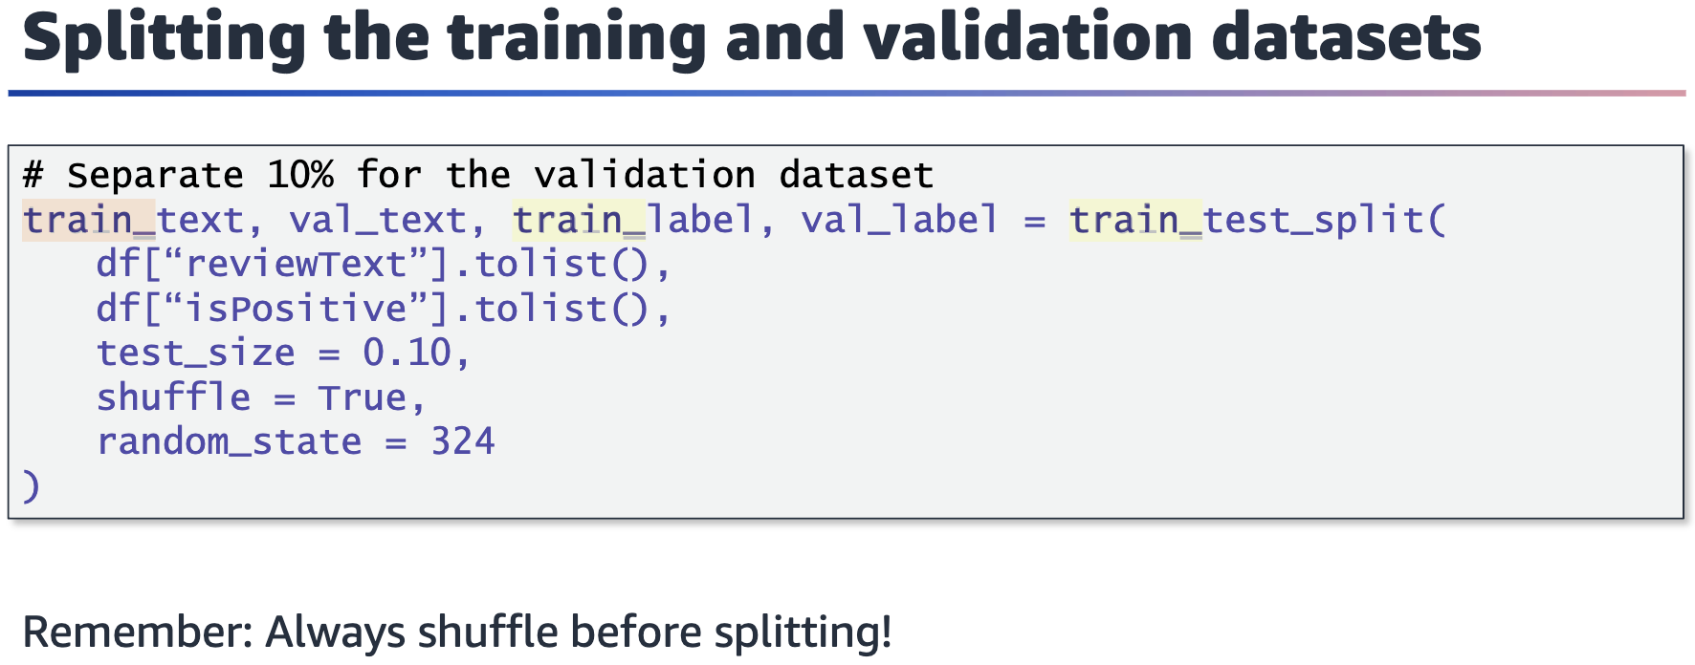

Sklearn’s train_test_split function uses array-like structures. The allowed inputs are lists, NumPy arrays, SciPy-sparse matrices, and Pandas DataFrames. Tensors, which are the preferred data structures in PyTorch, aren’t compatible with sklearn’s modules.

The test_size parameter can either be a float that represents the portion of the dataset to include in the test split, or it can be an integer that represents the absolute number of test samples.

The random state controls the shuffling that is applied to the data before the split. The random state is often used to generate reproducible outputs across multiple function calls.

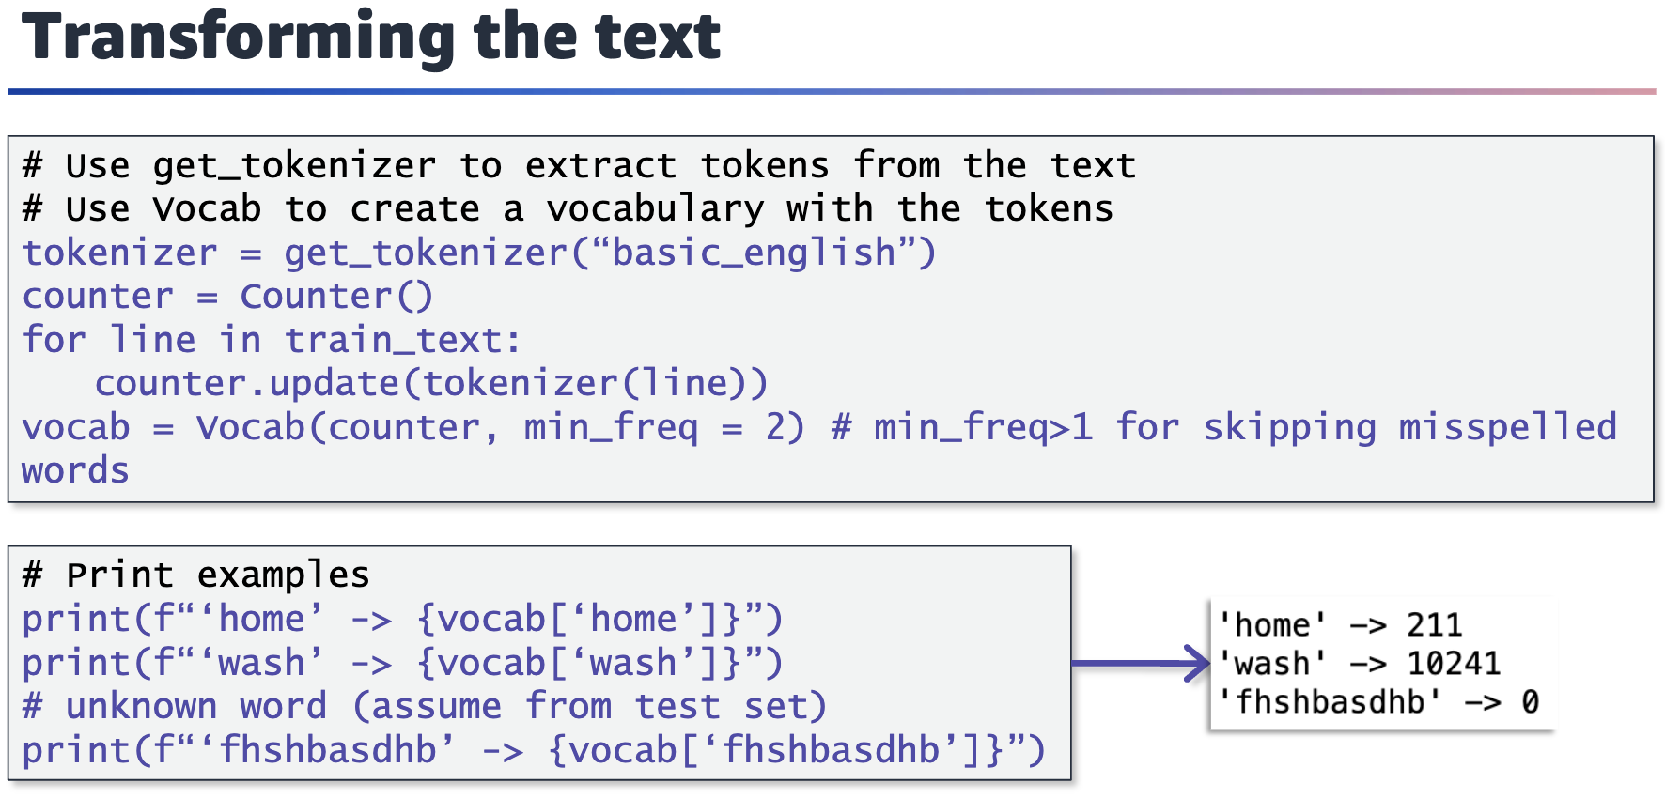

get_tokenizer requires a tokenizer function to generate tokens or requires the

language to select a preselected tokenizer for the specified language.

vocab (use l/c in init) is used to generate a vocabulary based on the training data. The min_freq parameter is set to 2 to avoid any misspelled words to be added in the vocabulary. This parameter can also be used to control the size of the vocabulary and prevent rare words, such as proper nouns, which often don’t contribute as much to the

meaning of the text.

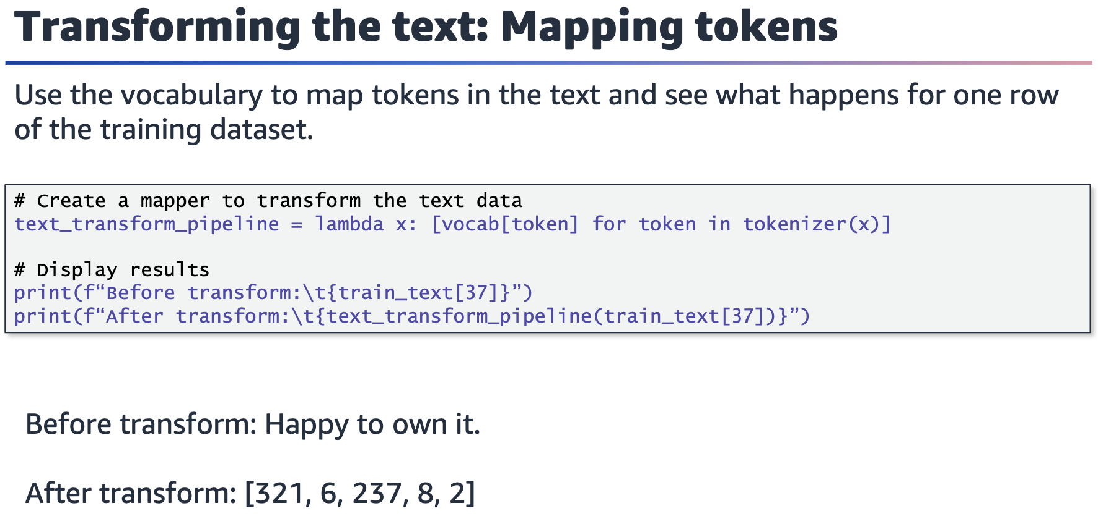

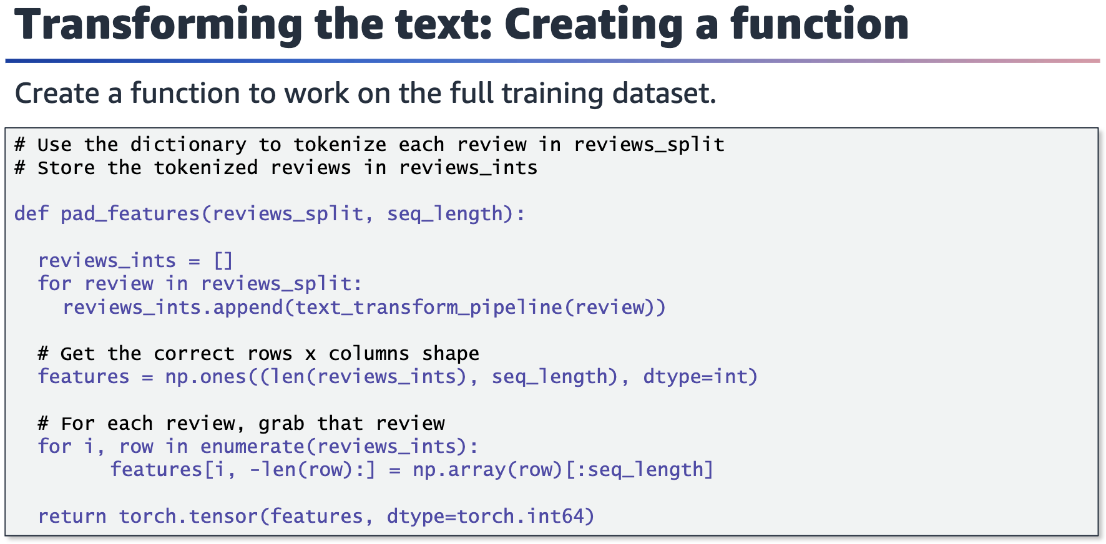

The pad_features function allows all transformed text to have the same sequence length of 50. An example is shown on the next slide. The 1s represent the padding that is applied to maintain the sequence length.

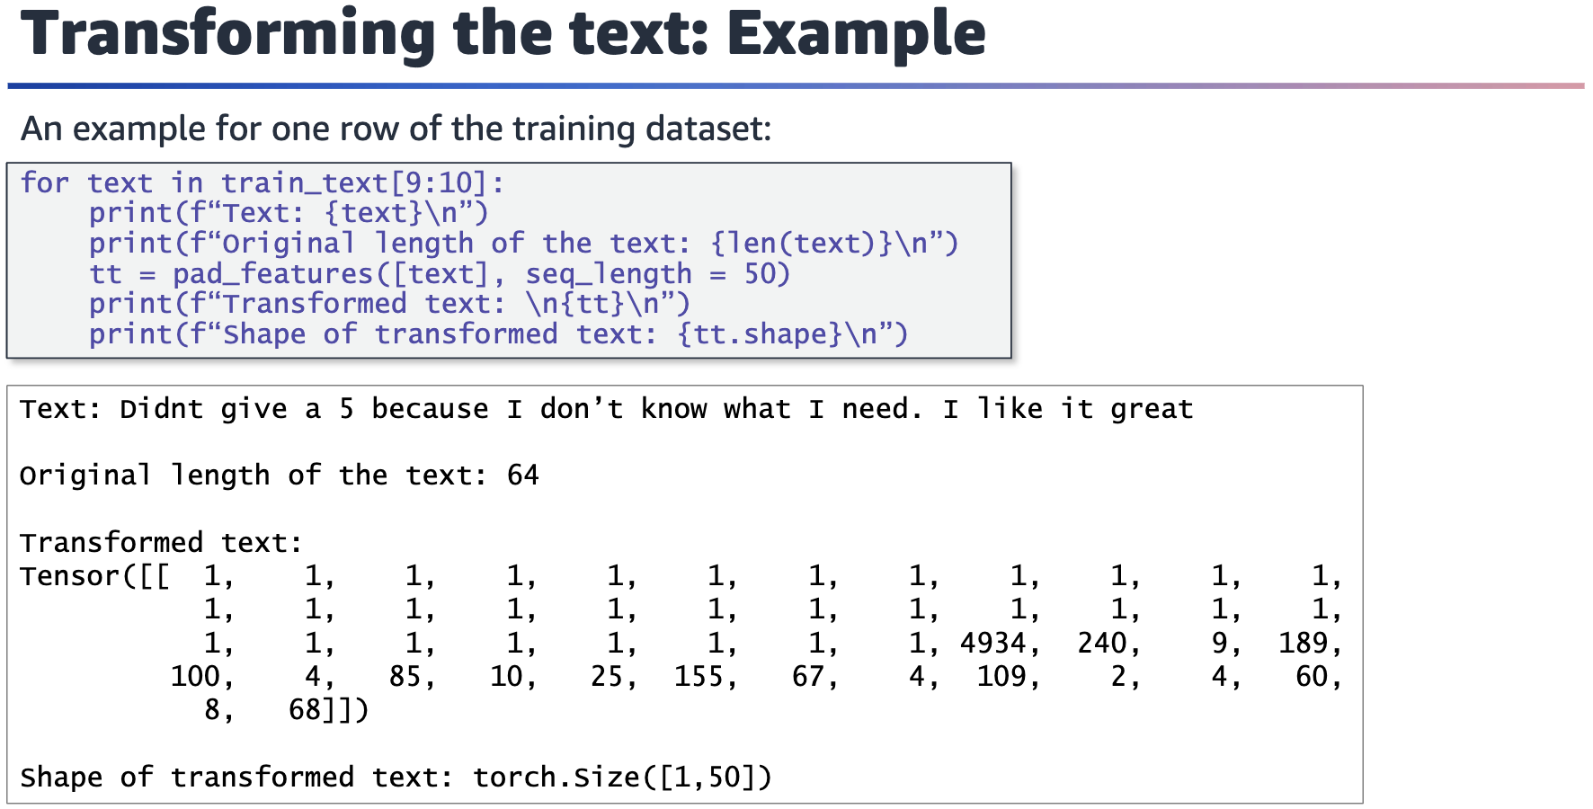

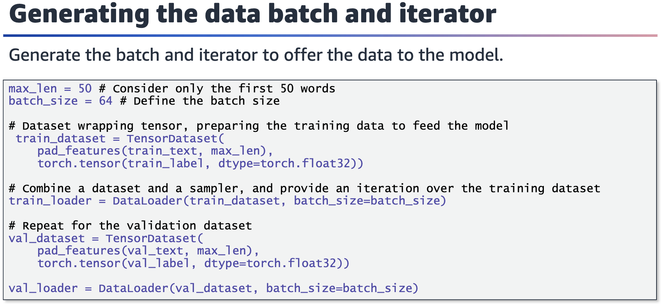

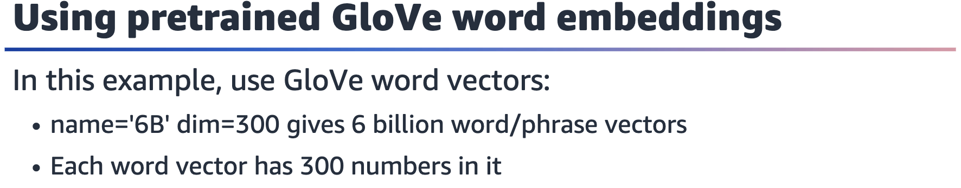



You can use the GloVe algorithm to obtain word embeddings by using unsupervised learning. In this example, a pretrained model is used to generate the word embeddings. The GloVe 6B model was trained on Wikipedia 2014 and Gigaword5, and it contains six billion unique tokens in its vocabulary. The dim parameter determines the dimension of the word embedding.

For more information about GloVe, see the GloVe: Global Vectors for Word Representation page at <https://nlp.stanford.edu/projects/glove>.

For more information about Gigaword5, see English Gigaword Fifth Edition on the Linguistic Data Consortium page at <https://catalog.ldc.upenn.edu/LDC2011T07>.

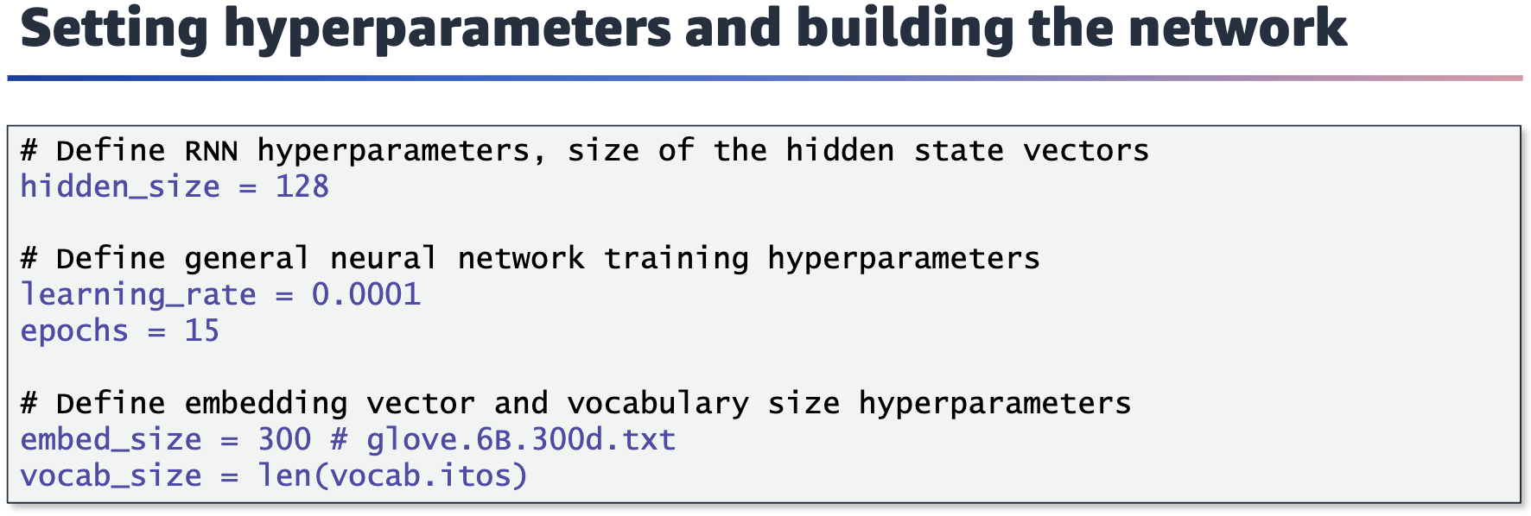

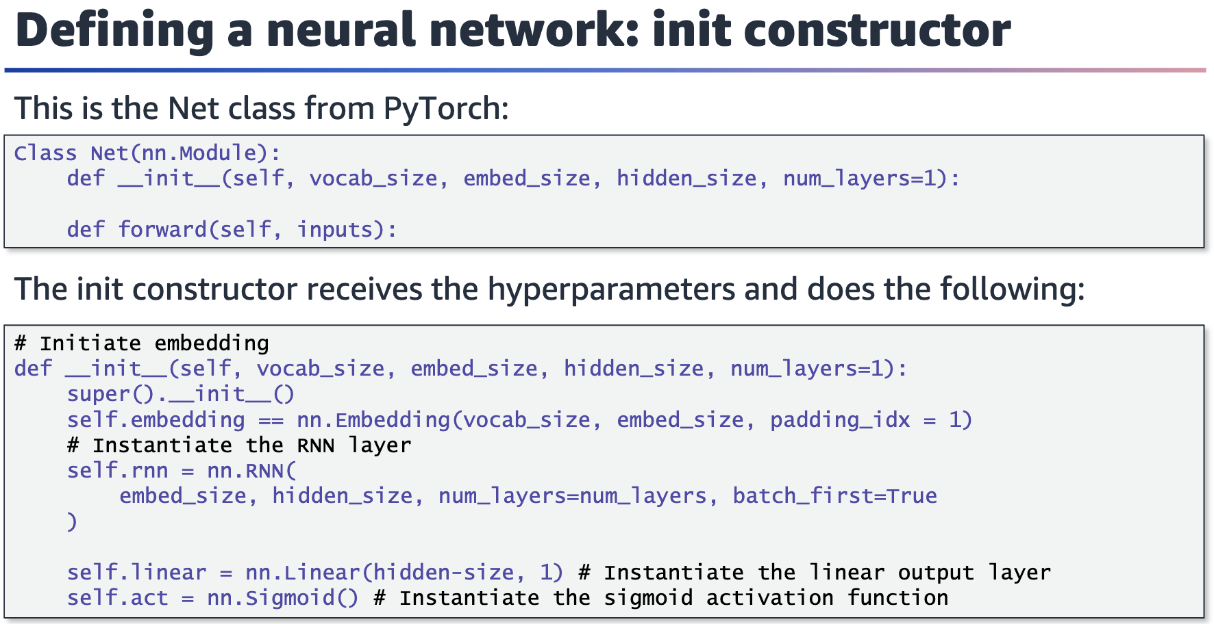



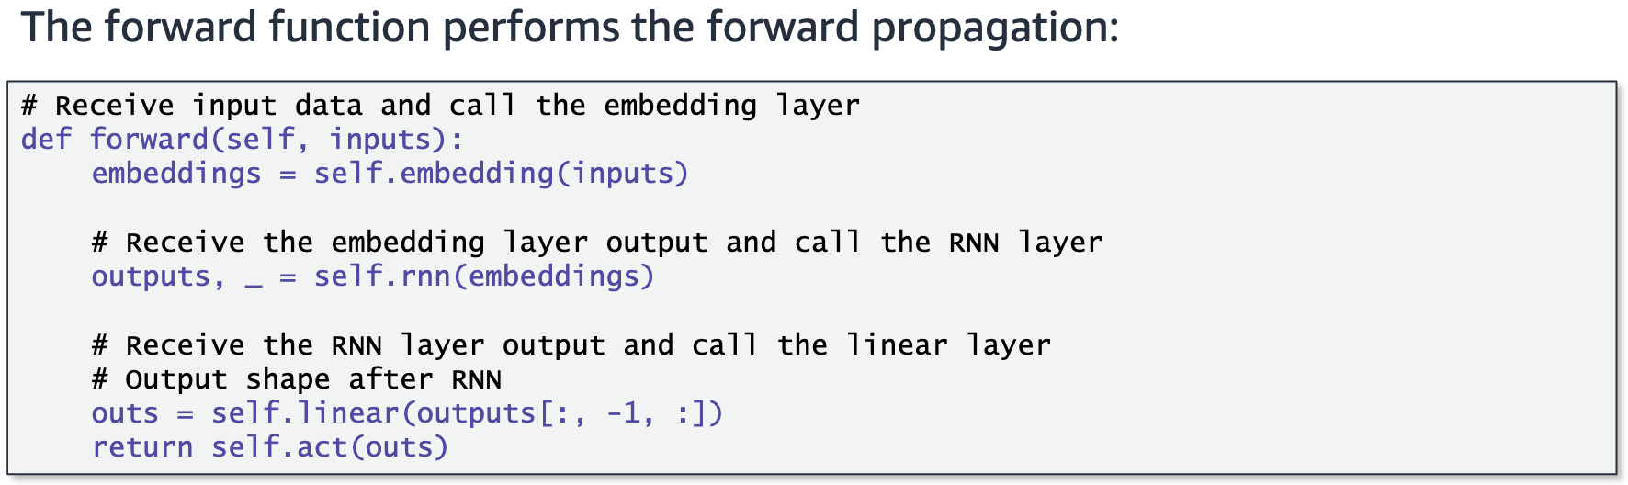

The forward function is used for prediction or a forward pass. It starts by generating

embeddings from the text input, followed by the RNN module to model this sequential data. Finally, a linear output layer processes the output of the RNN module and transforms it using the sigmoid activation for the binary classification task.

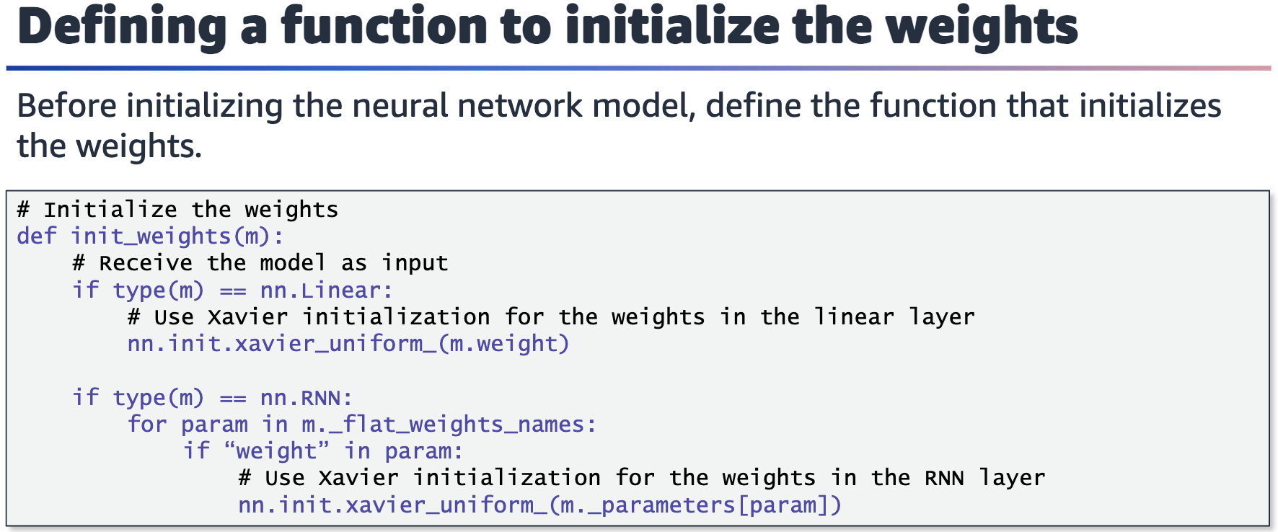

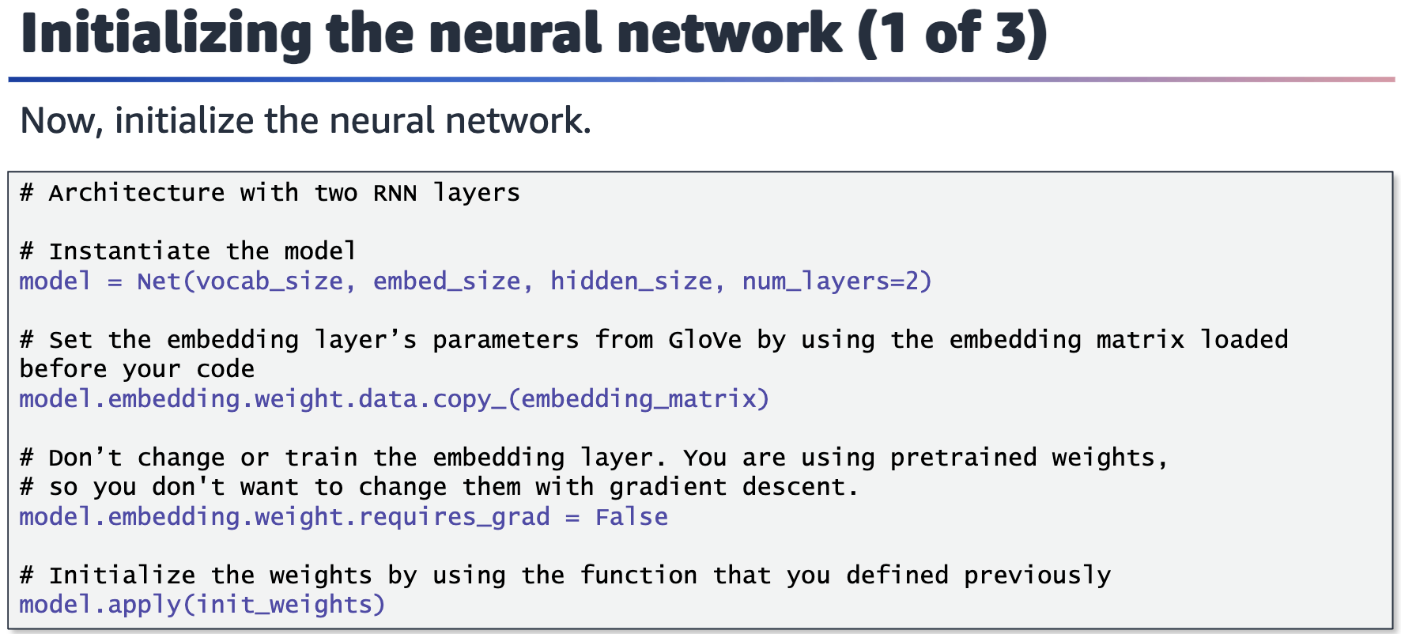

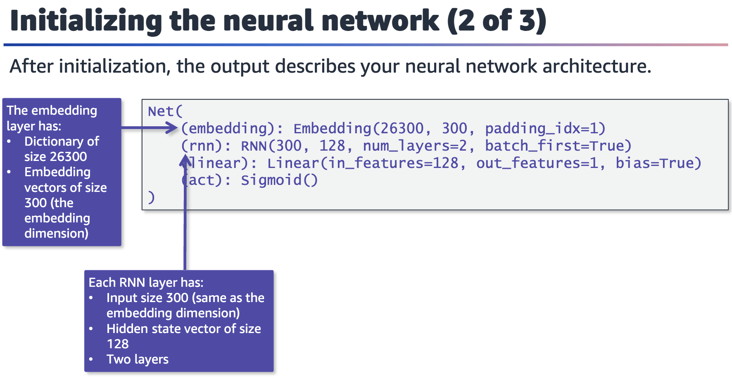

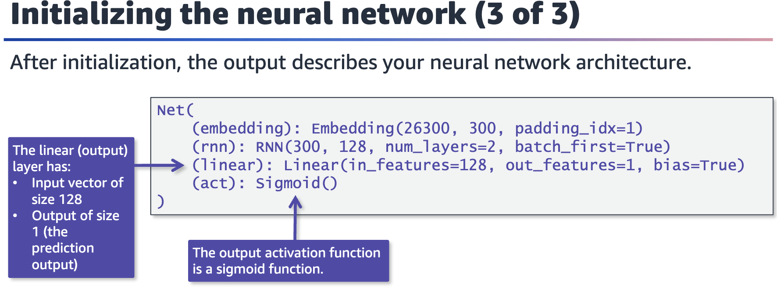



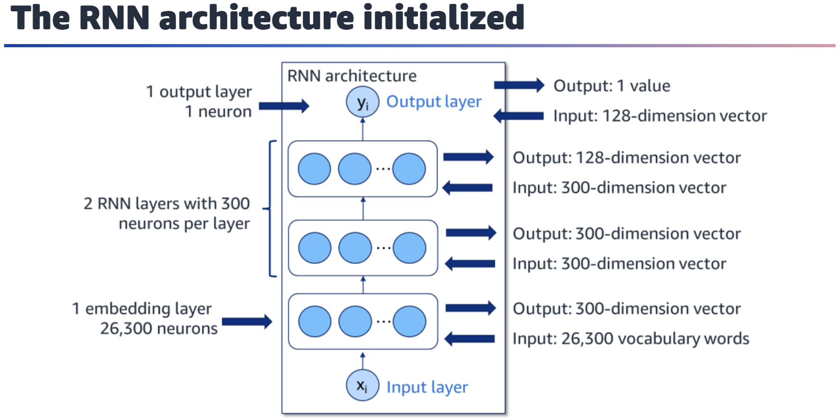

Typical RNN architecture with input layer x_i, output layer y_i, and one embedding layer of 26,300 neurons. The architecture also has two RNN layers with 300 neurons in each layer

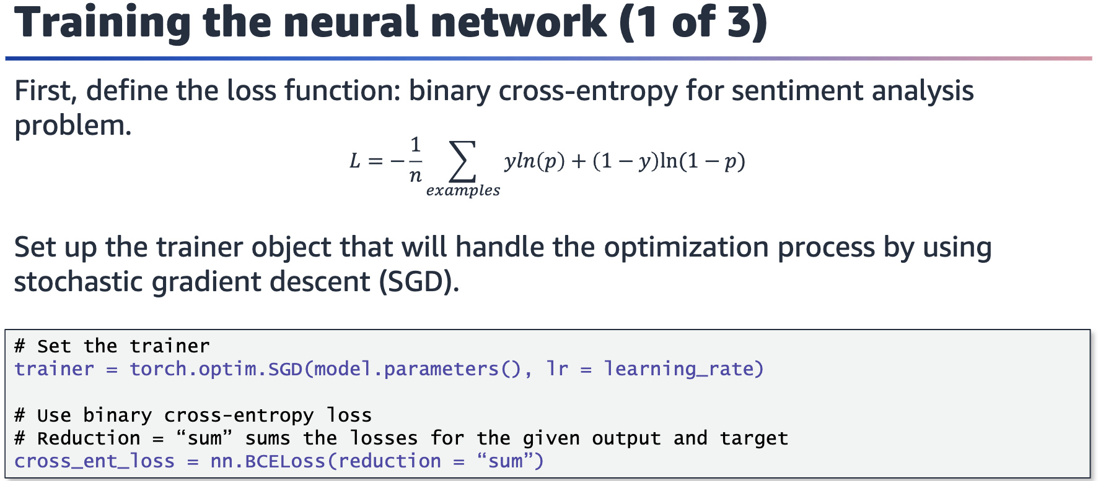

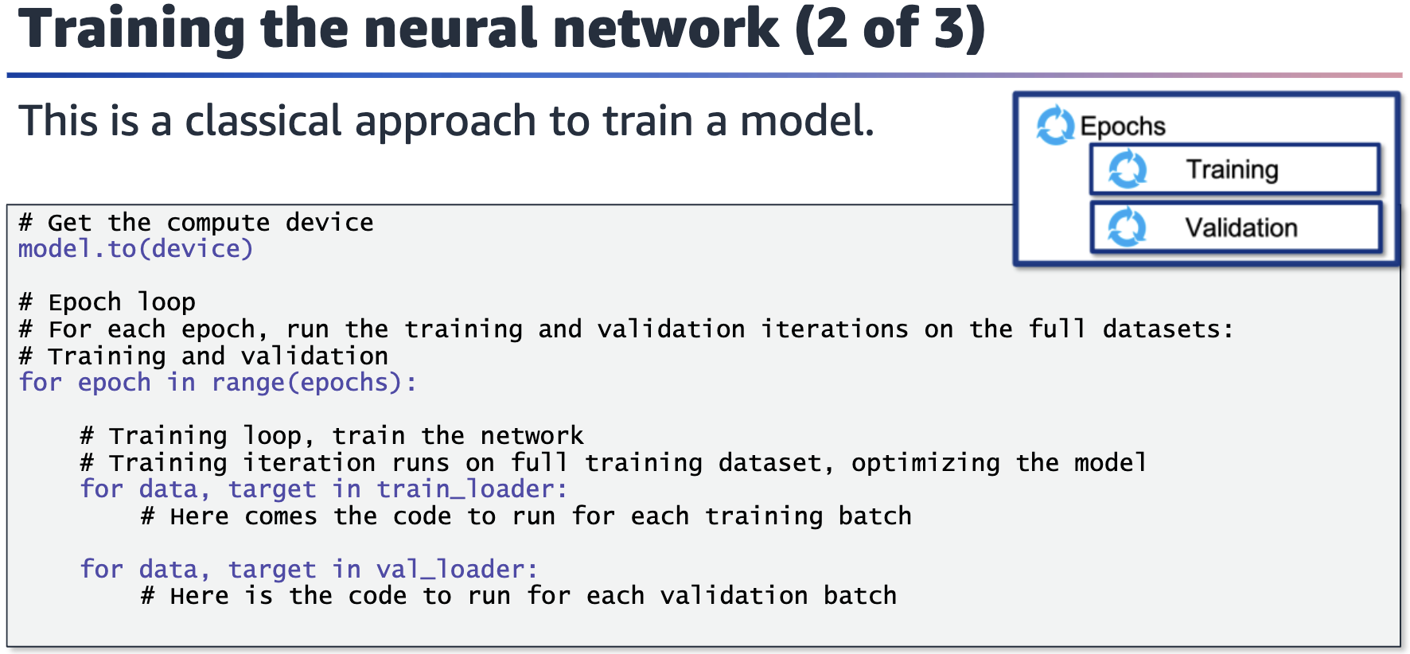

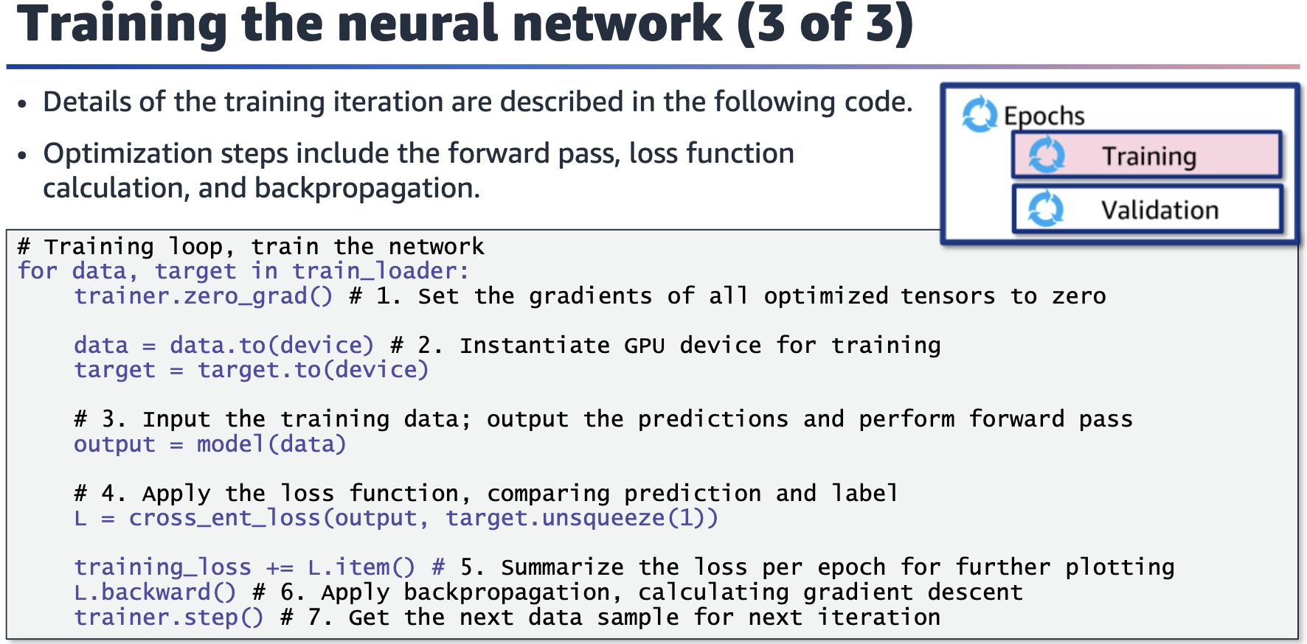

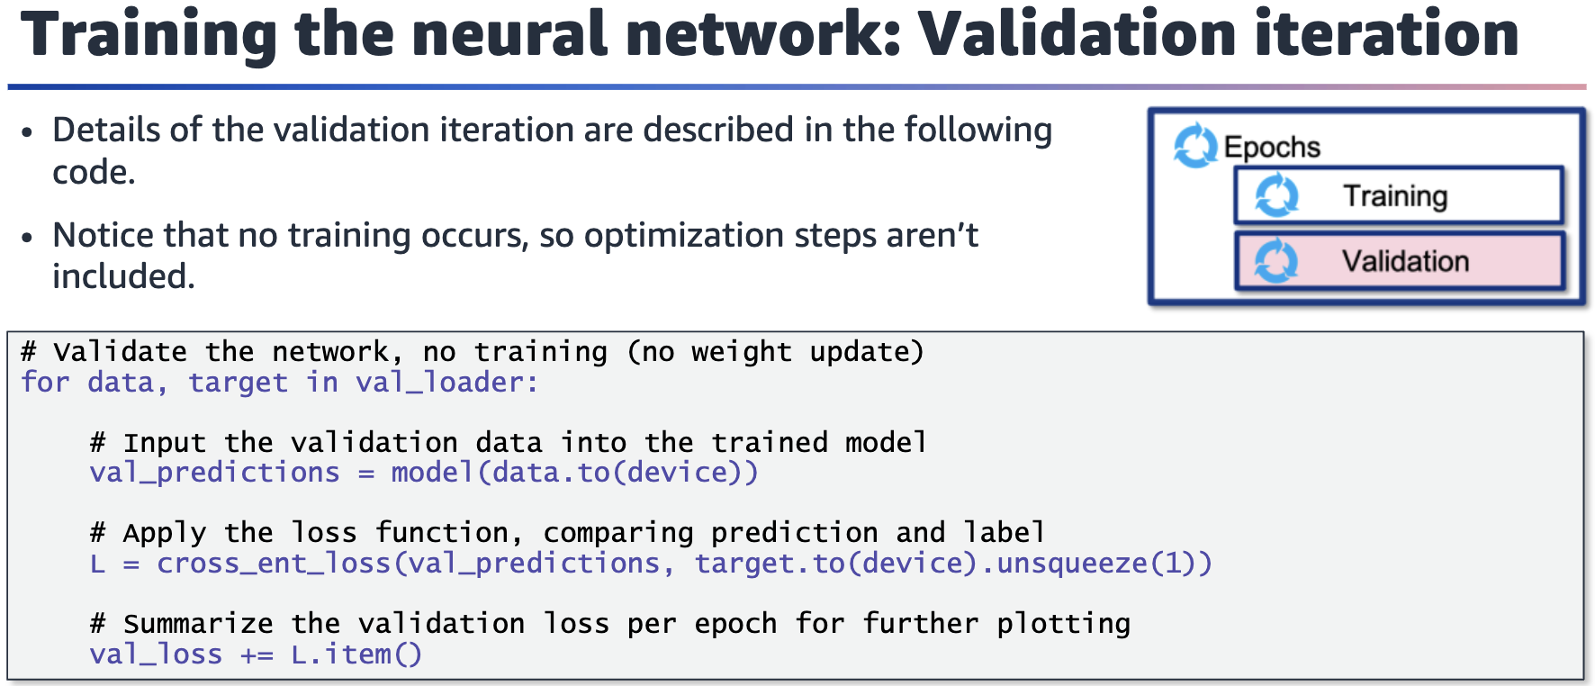

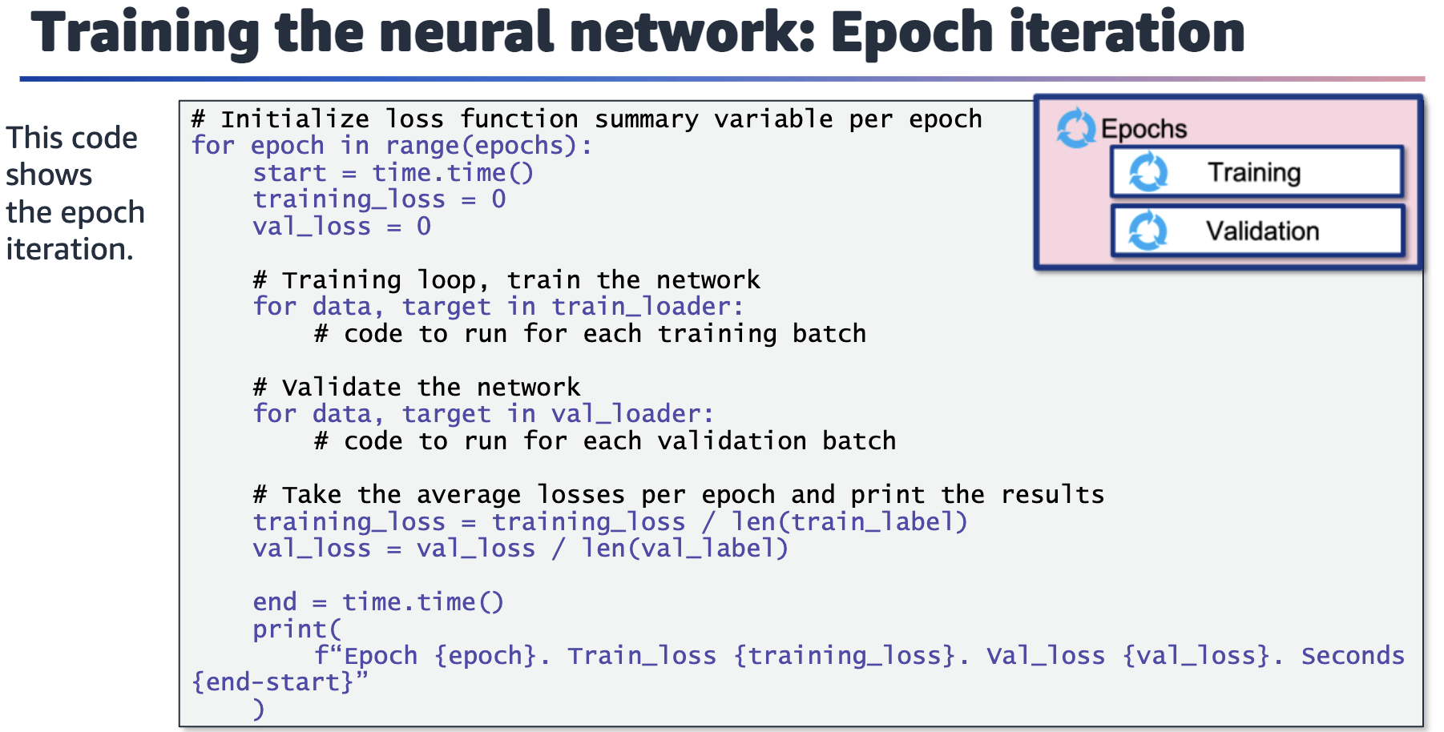

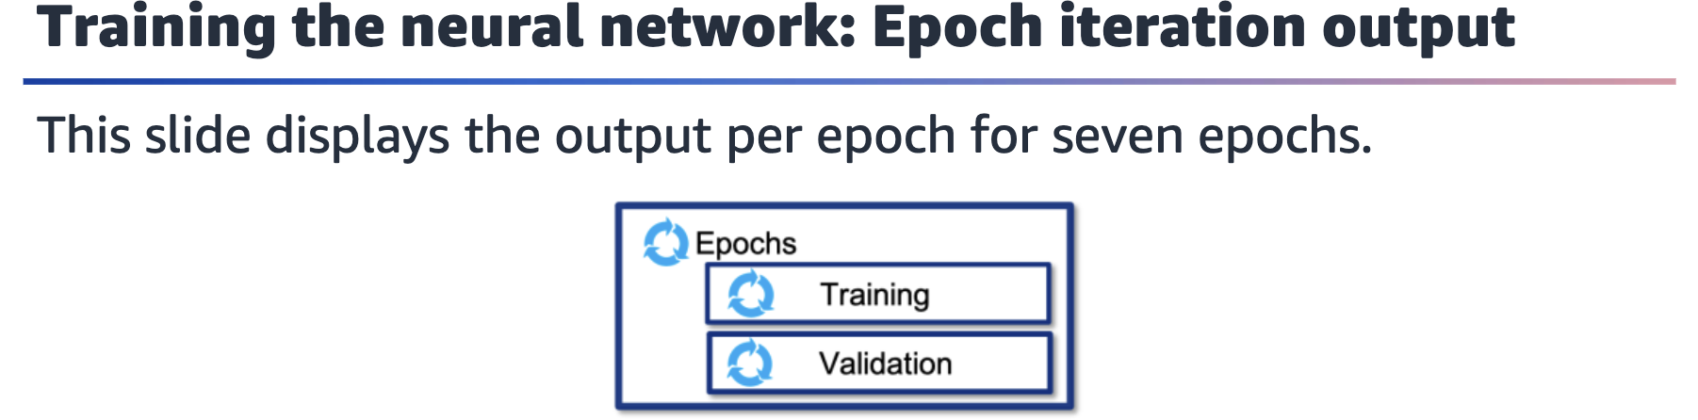

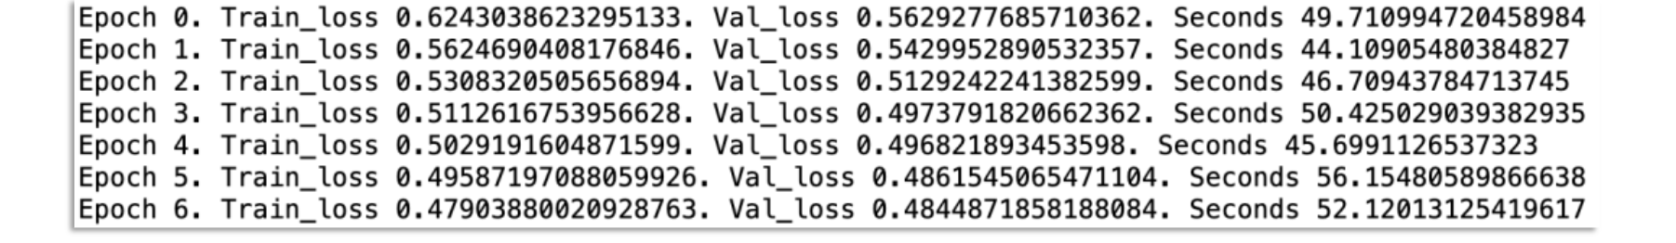

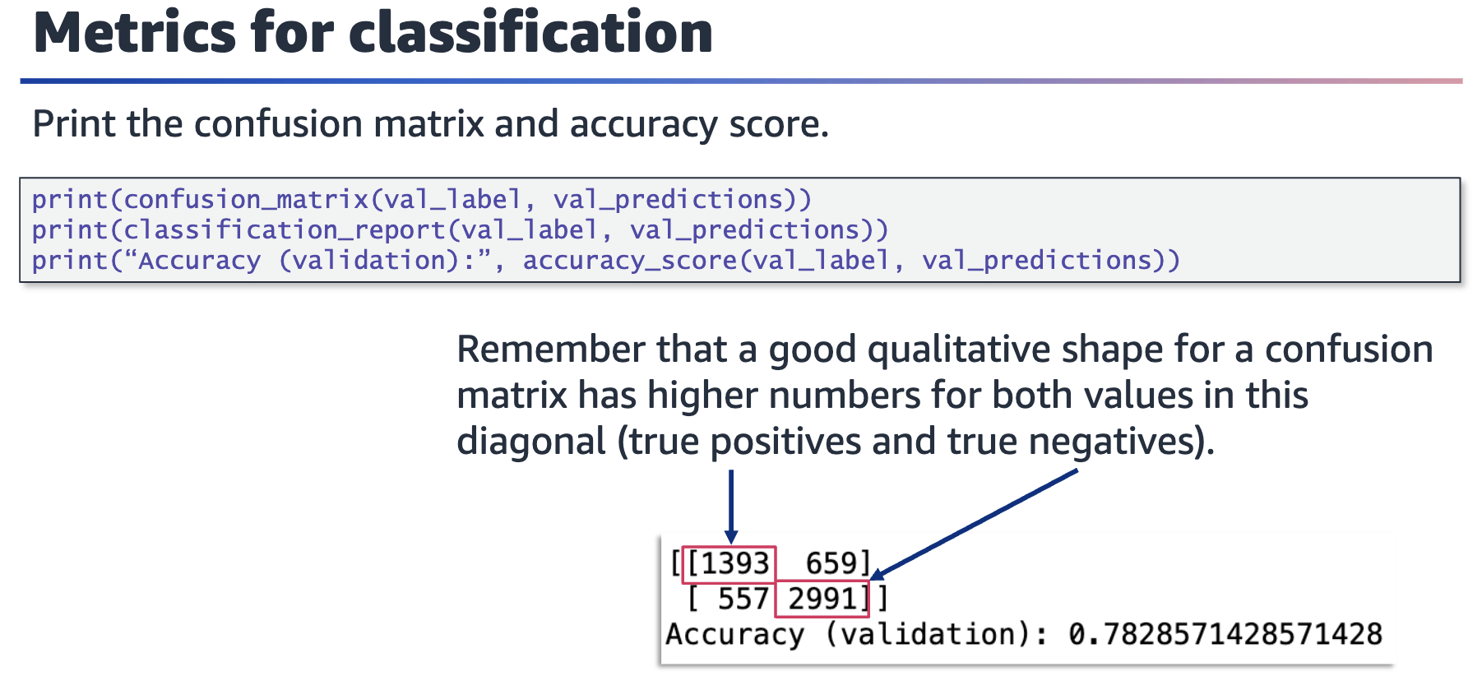

Screenshot of the output of the code. Includes the accuracy based on the confusion matrix values, including true positives, true negatives, and the accuracy (total of true positives and true negatives divided by the total number)

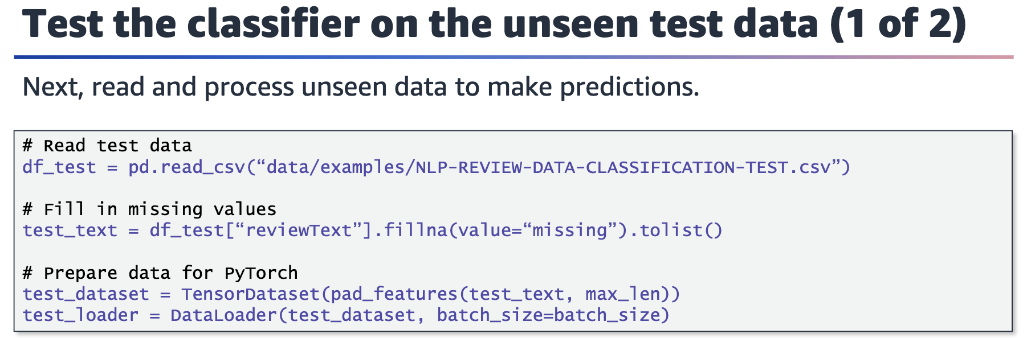

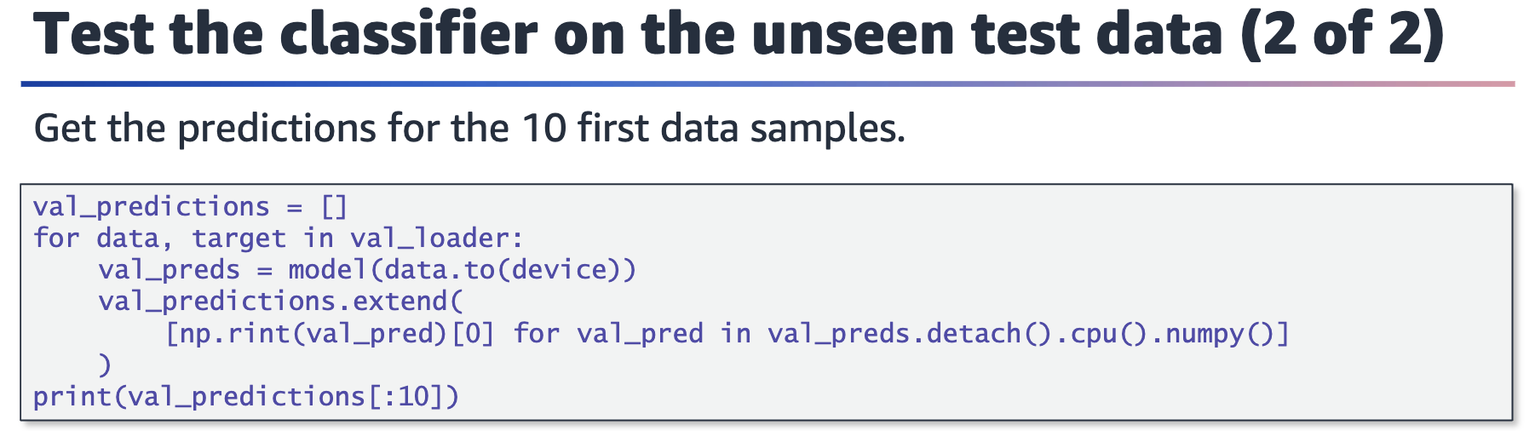

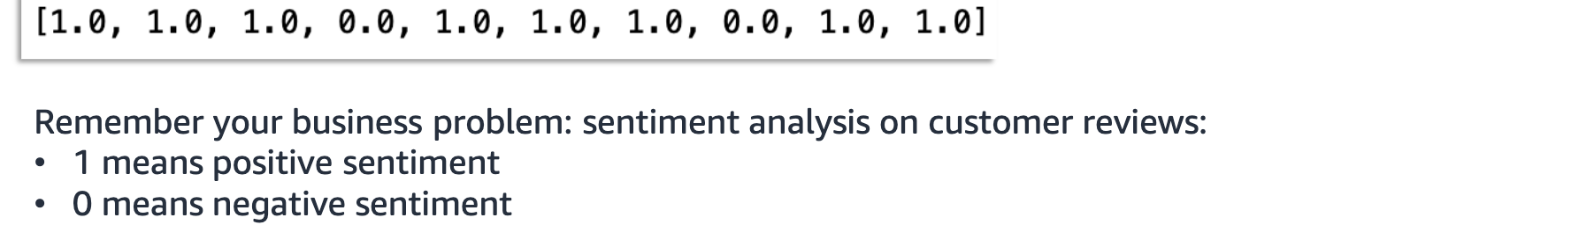

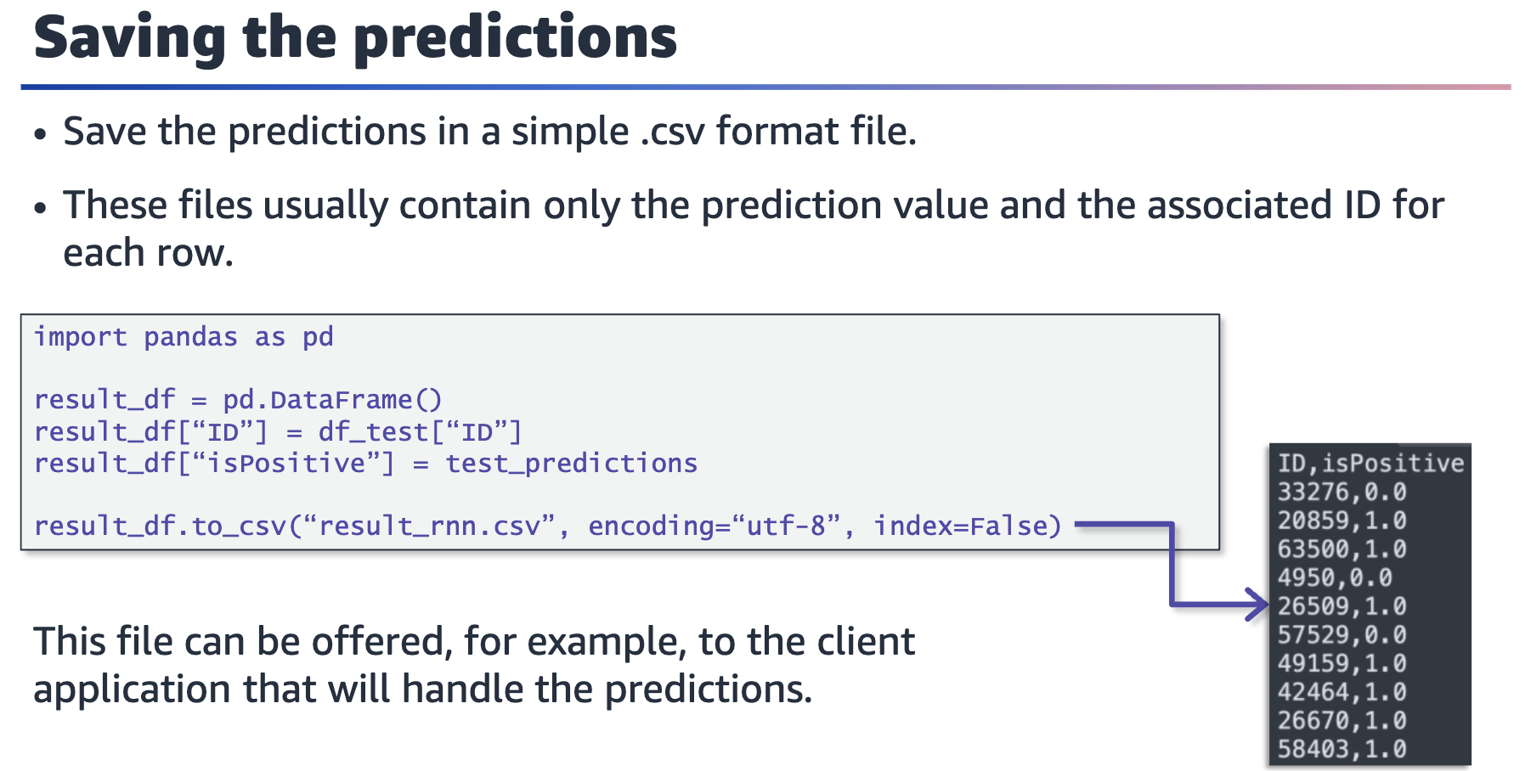

Example .csv output. The output contains two columns: ID and isPositive. The values for ID are four or five digits long, and the values for isPositive are 0 or 1.

